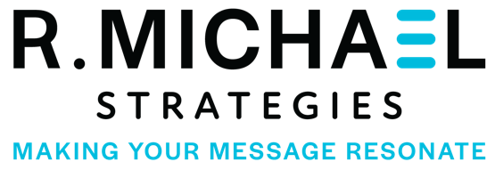

**RD2035**

Website and Asset Creation Project

R Michael Strategies will create an attractive, user-friendly website and a subsequent asset bank for newsletters and other communication needs. Below you will find a break out of the various elements and costs to create the content needed to successfully execute this project.

**Deliverables**

**Website:**

* Create a website to help improve user experience and communications.
* Work with staff to determine copy, assets and section needed to develop.
* Draft new and edit all copy to increase readability.
* Design website to increase usability for visitors, members, landowners and staff.
* Create ability to post minutes/agendas and other necessary items as required by state governance.
* Create ability to post news and various copy and attachments as needed.
* Navigational tabs to better direct users to specific needs and sections.
* Update all photos and add video as possible/needed.
* Include photos and listing of board members and staff.
* Incorporate new logos and brand guidelines.
* Ensure site meets ADA requirements and regulations.

**Asset Creation:**

* **Still Photography 100 photos for usage**
  + Shots of landowner fields, irrigation systems, drainage canals, etc.
  + Land-based and aerial shots of Sacramento River.
  + Shots of any water infrastructure sites as designated by client.
  + Shots of headquarters, landmarks, etc.
  + District Board Members and Staff group/individual photos.
* **Graphic Design**
  + Create graphic assets to help fill out website as needed
  + Update color pallet of current RD2035 logo
  + Create brand guidelines for future printing, digital needs

**Costs:**

**Website: $ 10,000**

**Asset Creation: $ 5,000**

Photography (aerial/ground): $ 4,000

Logo Update: $ 1,000

**TOTAL: $ 15,000.00**