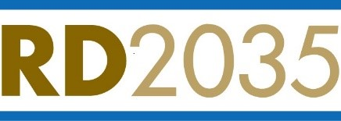

RECLAMATION DISTRICT 2035
Board of Trustees Emergency Meeting
February 20, 2025
9:30 a.m.

Teleconference: (669) 900-6833
Meeting ID: 846 9668 4185
International numbers available: https://kmtg.zoom.us/u/kdGUosICQ5
Join from PC, Mac, Linux, iOS or Android: https://kmtg.zoom.us/j/84696684185

Item: Presented By: Action Needed:

1. Call to Order President Information

2. Roll Call President Information

3. Declaration of Emergency Jesse Clark Action
Jay Punia
Eric Robinson

4. Delegation of Authority Letter Jesse Clark Information
Jay Punia
Eric Robinson

